**St David's Day Placemat**

**Decorate the table for St David's Day with this pretty St David's Day placemat in Welsh colours. This paper weaving is fun to do and very effective.**

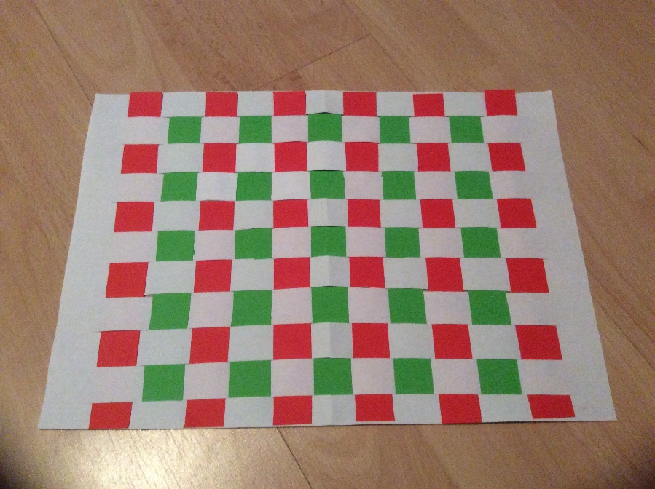

**You will need:**

**Sheet of white card / paper  
Green and red paper**

**Instructions:**

* **Fold the white card in half lengthways. Cut long lines in the card about 1 inch apart and about 1 inch from the edge of the card.**

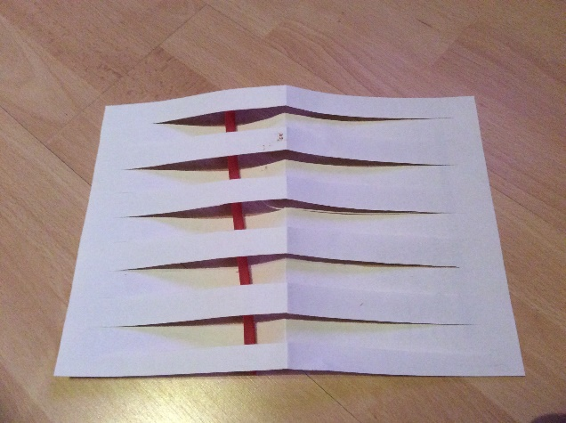

* **Cut the green and red paper into strips about 1 inch wide.**

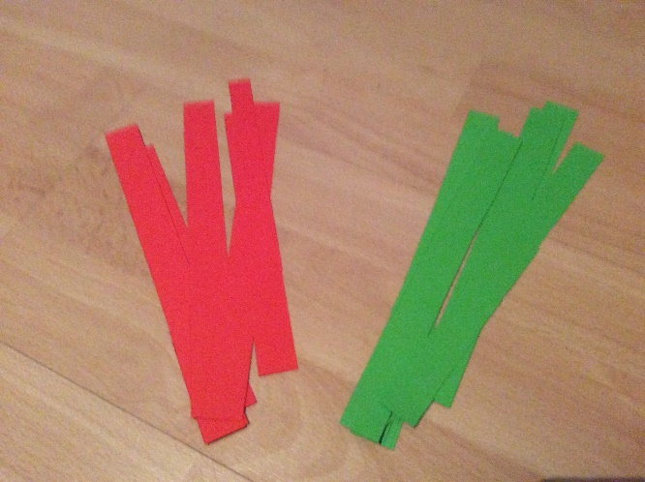

* **Take a strip of paper and pass it under the card and then up through the first slit, down through the second and back up through the third and so on until you reach the other side of the card.**

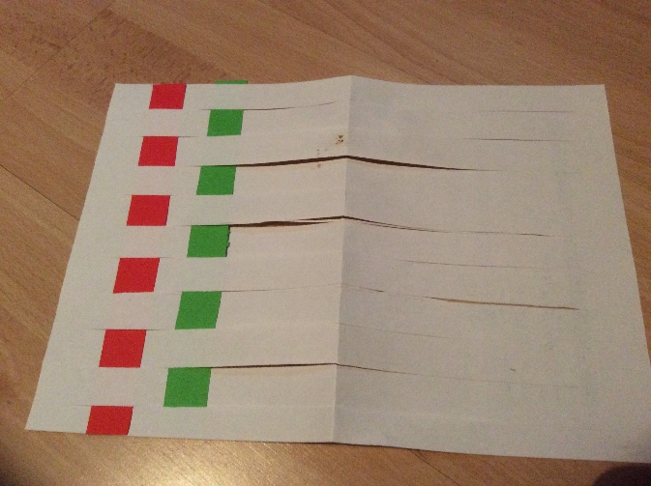

* **Push the coloured paper up so it sits as close to the top of the white card as it can reach.**
* **Repeat with a different coloured strip of paper, starting the other way, down through the first slit and up through the second and so on. Repeat until the card is full.**
* **If you can, laminate your mat so that you can wipe it clean after your St David’s day meal.**