**Egg Box Daffodils**

Welcome St David's Day with these pretty handmade daffodils.

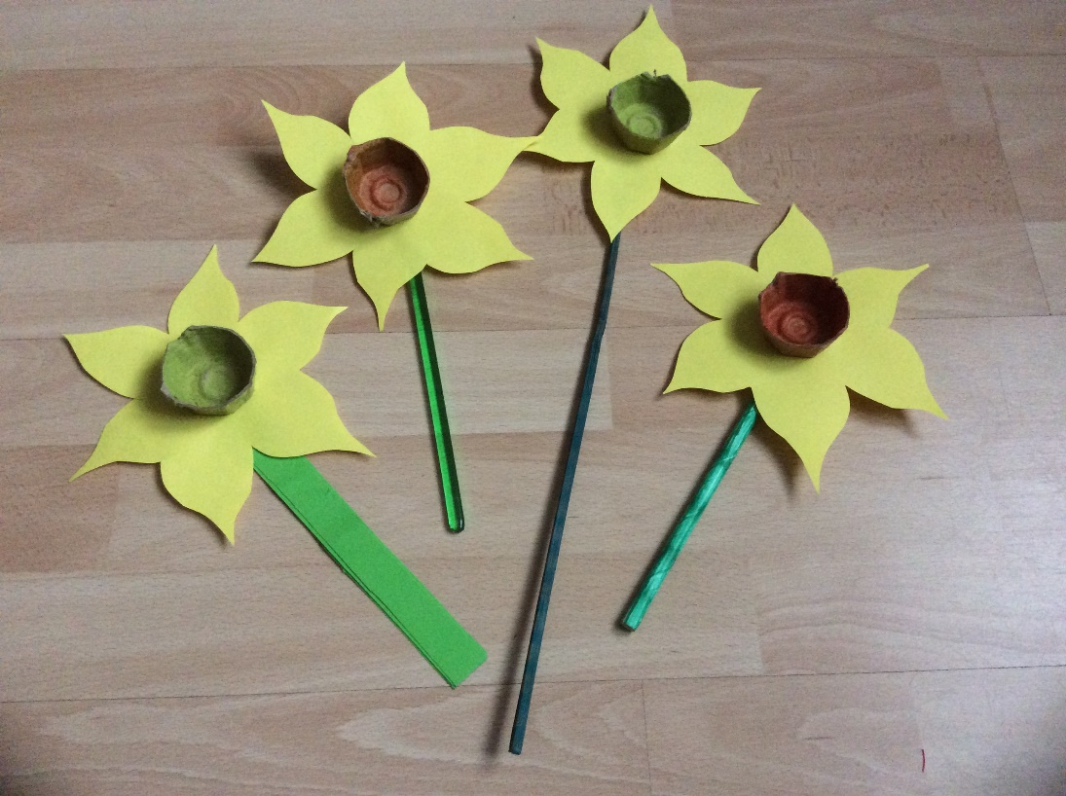

**You will need:**

Egg box  
Orange / yellow / Green paint or felt pens  
Yellow card / paper  
Glue / Scissors  
Drinking straws / plastic sticks / garden stakes  
Sticky tape

**Instructions:**

* Cut the egg box into the individual sections,
* Paint or colour the bottom of an egg box. Leave to dry.
* Cut out flower shapes from card / paper.
* Glue the egg boxes to the centre of the flower shapes to make the trumpet.
* Tape a green coloured straw / stick to the back of each daffodil.